Demonstrations and Descriptions
Hamstrings: You'll want to try these with the feet turned in, out, and pointing straight ahead to completely work the entire hamstring complex. Balance on your hands with your hamstrings resting on the roller, then roll from the base of the glutes to the knee. To increase loading, you can stack one leg on top of the other.
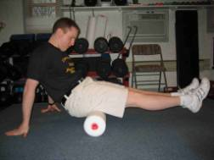
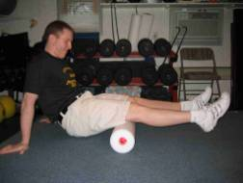
Hip Flexors: Balance on your forearms with the top of one thigh on the roller. Roll from the upper thigh into the hip. Try this with the femur both internally and externally rotated. To do so, just shift the position of the contralateral pelvis. (In the photo, Mike would want to lift his right hip to externally rotate the left femur).
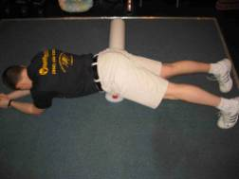
Tensor Fascia Latae and Iliotibial Band: These are a little tricky, so we've included pictures from two different angles. Without a doubt, this one will be the most painful for most of you.
In the starting position, you'll be lying on your side with the roller positioned just below your pelvis. From here, you'll want to roll all the way down the lateral aspect of your thigh until you reach the knee. Stack the opposite leg on top to increase loading.
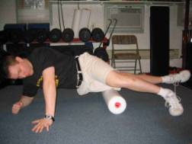
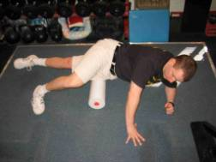
Adductors: Balance on your forearms with the top of one of your inner thighs resting on the roller. From this position, roll all the way down to the adductor tubercle (just above the medial aspect of the knee) to get the distal attachments. You'll even get a little vastus medialis work in while you're there. Watch out for your twig and berries on this one, though!
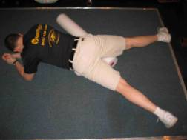
Quadriceps: This one is quite similar to the hip flexor version; you're just rolling further down on the thigh. You can perform this roll with either one or two legs on the roller.
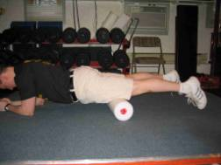
Gluteus Medius and Piriformis: Lie on your side with the "meaty" part of your lateral glutes (just posterior to the head of the femur) resting on the roller. Balance on one elbow with the same side leg on the ground and roll that lateral aspect of your glutes from top to bottom.
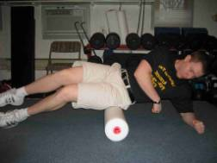
Gluteus Maximus: Set up like you're going to roll your hamstrings, but sit on the roller instead. Roll your rump. Enough said.
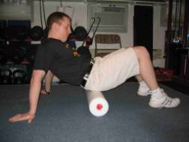
Calves: This, too, is similar in positioning to the hamstrings roll; you're just rolling knee to ankle. Try this with the toes up (dorsiflexion) and down (plantarflexion). Stack one leg on top of the other to increase loading.
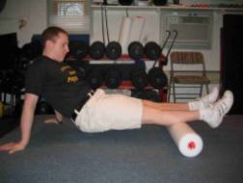
Tibialis Anterior: This is just like the quad roll, but you're working on your shins instead.
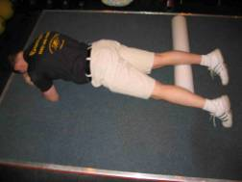
Peroneals: This one is similar to the TFL/ITB roll; we're just working on the lower leg now. Roll along the lateral aspect of the lower leg from the knee to the ankle.
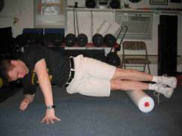
Thoracolumbar Fascia: With your arms folded across your chest, lie supine with the roller positioned under your midback. Elevate the glutes and roll from the base of the scapulae to the top of the pelvis. You'll want to emphasize one side at a time with a slight lean to one side.
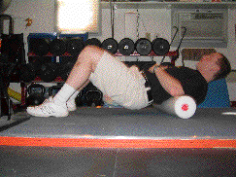
Thoracic Extensors, Middle and Lower Trapezius, Rhomboids: With your arms behind your head (not pulling on the neck), lie supine with roller positioned in the middle of your back; your glutes should be on the ground. Roll upward, reversing direction when you reach the level of the armpits. This is an excellent intervention for correcting kyphosis.
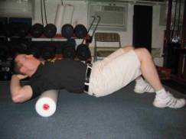
Latissimus Dorsi and Teres Major: Lie on your side with the same side arm overhead. The roller should be positioned at the attachment of the lat on the scapula in the starting position. You'll want to roll toward the attachment on the humerus (roll toward the armpit).
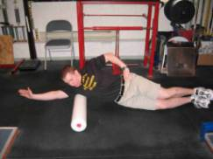
Triceps: Start with your body in the same position as you would for the latissimus dorsi. Now, however, you'll want to place the roller at the top of your triceps (near your armpit) and your noggin on top of your arm to increase the tension (and no, you don’t have to be that geeky kid from Jerry Maguire to know the human head weighs 8 pounds!)
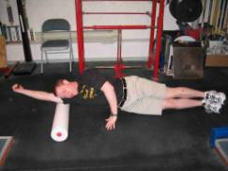
Pectoralis Major and Anterior Deltoid: Lie prone with the roller positioned at an angle slightly to one side of the sternum; the arm on this side should be abducted to about 135° (halfway between completely overhead and where it would be at the completion of a lateral raise). Roll toward the humeral head (toward the armpit).


